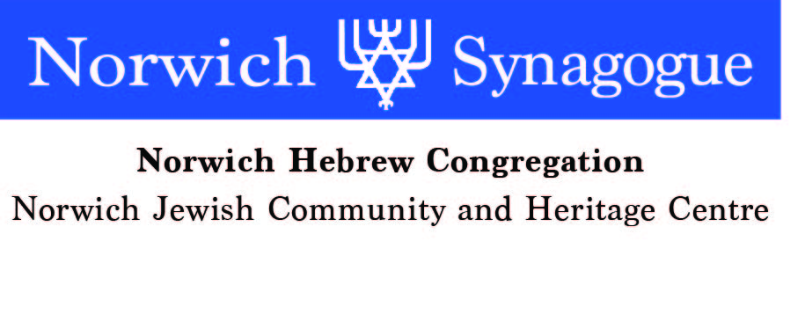
c

Application for Joint/ Family Membership
(Please use different form for Individual membership)
Available only to Jewish People
If you have any difficulty completing this form please do speak to a member of the committee.
Name …………………………………………….. Date of Birth ………………..

Address ………………………………………………………………………………

………………………………………………………………………………………...

Tel No. ……………………….. Email address ……………………………...............

Partner’s name ……………………………………… Date of Birth………………..

Tel No………………………..Email address………………………………………..

Children under 25:

Name ……………………………………………………….Age ………………m /f…..

………………………………………………………………Age ………………m/f…..

………………………………………………………………Age……… ………m/f…...

Details of previous or present Synagogue membership (if applicable)

……………………………………………………………………………………….....

Jewish Marriage (if applicable):

Synagogue where (or under whose auspices) your marriage took place and date:-

……………………………………………………………………………………

Please provide copy evidence of Jewish marriage. Attached – Yes/ No

PTO

If no Jewish marriage, please provide details / evidence of each partner’s Jewish identity (including details of conversion to Judaism if applicable)

……………………………………………………. ……………………………………….

………………………………………………………………………………………….

………………………………………………………………………………………….

…………………………………………………………………………………………..

……………………………………………………………………………………………

……………………………………………………………………………………………

Hebrew names (if known)……………………………………………………………..

…………………………………………………………………………………………...

…………………………………………………………………………………………..

Names and dates of any Yahrzeits which you would wish to have marked (please give English and Hebrew names if known, and their relationship to you)…………………………

…………………………………………………………………………………………

…………………………………………………………………………………………

Signature …………………………………………………… Date …………………..

Please Email to: enquiries@norwichsynagogue.org.uk
Or post to: The Membership Secretary
Norwich Synagogue
3 Earlham Rd
Norwich NR2 3RA

The Synagogue committee, at its next meeting, will consider your application. Copies of relevant documents relating to your marriage or other Synagogue membership would be helpful.

