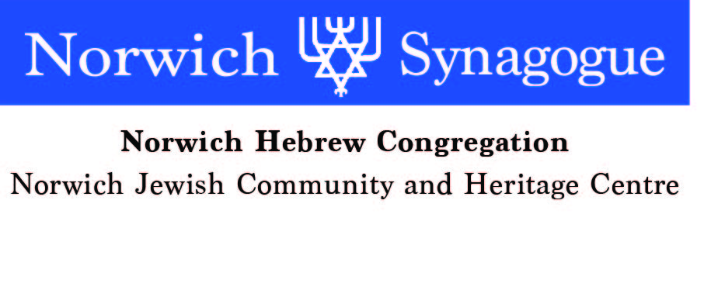
c

Application for Individual Membership
(Please use different form for Joint/ Family Membership)
Available only to Jewish People
If you have any difficulty completing this form please do speak to a member of the committee.

Name …………………………………………….. Date of Birth ………………..

Address ………………………………………………………………………………

………………………………………………………………………………………...

Tel No. ……………………….. Email address ……………………………...............

Details of previous or present Synagogue membership (if applicable)

……………………………………………………………………………………….....

Parents’ Jewish marriage (if applicable):

Synagogue where (or under whose auspices) their marriage took place and date

……………………………………………………………………………………..

Please provide copy evidence of parents’ Jewish marriage. Attached ? – Yes /No.

If parents had no Jewish marriage, please provide details/ evidence of each parent’s Jewish identity-
………………………………………………………………………………………
………………………………………………………………………………………
………………………………………………………………………………………
………………………………………………………………………………………
………………………………………………………………………………………….
………………………………………………………………………………………….
………………………………………………………………………………………….

PTO

Details of your conversion to Judaism (if applicable) ……………………………………….

………………………………………………………………………………………….

Hebrew name (if known)……………………………………………………………..

Names and dates of any Yahrzeits which you would wish to have marked (please give English and Hebrew names if known, and their relationship to you)……………

…………………………………………………………………………………………

…………………………………………………………………………………………

…………………………………………………………………………………………

…………………………………………………………………………………………

Signature …………………………………………………… Date …………………..

Please Email to: enquiries@norwichsynagogue.org.uk
Or post to: The Membership Secretary
Norwich Synagogue
3 Earlham Rd
Norwich NR2 3RA

The Synagogue committee, at its next meeting, will consider your application. Copies of relevant documents relating to your marriage or other Synagogue membership would be helpful.

