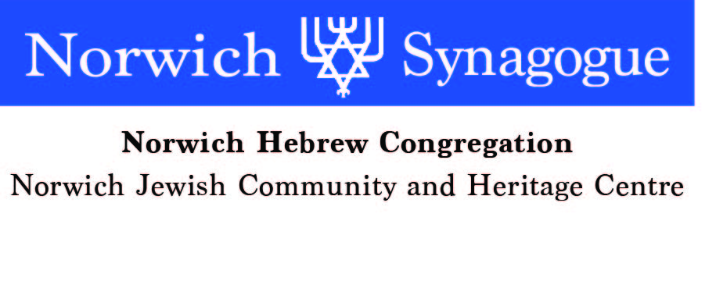
c

Application for Membership as a Friend
(Not available to Jewish people)

Name …………………………………………….. Date of Birth ………………..

Address ………………………………………………………………………………

………………………………………………………………………………………...

Tel No. ……………………….. Email address ……………………………...............

Reason for your application (eg family or other connection with a named full member, intention to undertake conversion to Judaism, wish to support the Jewish community, interest in occasional visits to services and /or social events ). Please give details-
………………………………………………………………………………………………….

…………………………………………………………………………………………………

…………………………………………………………………………………………………

…………………………………………………………………………………………………

………………………………………………………………………………………………….

…………………………………………………………………………………………………

………………………………………………………………………………………………

Signature …………………………………………………… Date …………………..

Please Email to: enquiries@norwichsynagogue.org.uk
Or post to: The Membership Secretary
Norwich Synagogue
3 Earlham Rd
Norwich NR2 3RA

The Synagogue committee, at its next meeting, will consider your application

